Few other papers that speak about clock synchronization in intersection with AI/ML:
Paper: Multi-hop Precision Time Protocol: an Internet Applicable Time Synchronization Scheme
approximately 3 times the precision of HUYGENS
HUYGENS’s synchronization is only applicable to symmetrical structure of the data center.
Multi-hop Precision Time Protocol (M-PTP) is especially suitable for Internet-scale high-precision time-synchronized scenes and with low cost.
M-PTP leverages two key ideas. First, to mitigate the “asymmetry in forward delay and reverse delay” problem, SVM-based delay estimation is used to calculate the distribution of positive and negative random delays, then L-estimator is leveraged to estimate the time offset. Second, based on time offset, M-PTP exploits loop effect optimization among nodes. We implemented the protocol and tested its performance on variance hops under different traffic conditions and CPU loads. The experimental results show that M-PTP can achieve a precision of 11.61ns at 5 hops, which is approximately 3 times the precision of HUYGENS and approximately 30 times the precision of PTP.
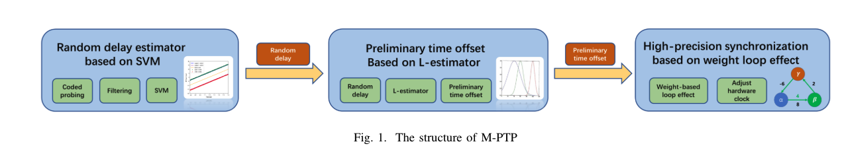

Data: Multiple M-PTP nodes probe one by one and form a probe loop. The sum of the offset values between all adjacent probing nodes in this loop should be zero. If the sum does not equal 0, it should be caused by an inaccurate estimation of the offset value. This feature can be used to further improve the estimation precision of the offset value. M-PTP considers the historical time offset and allocates the residual sum of time offset more accurately based on the loop weight. The experimental results show that it further improved the precision of the M-PTP protocol.
Process: In the first step, M-PTP encodes and filters the packets to obtain packets that are less affected by the delay of network equipment, obtains the upper and lower bounds, and estimates the random delay based on SVM. Then, M-PTP uses the L-estimator to estimate the preliminary time offset. Finally, in the third step, M-PTP performs loop correction based on the weight to obtain the final time offset, and adjusts the hardware clock.
M-PTP leverages back-to-back packets to filter the packets that are affected by the delay of network equipment and to obtain packets that are less affected by the delay of network equipment. Then it performs SVM on the filtered data and calculates the random delay distribution.
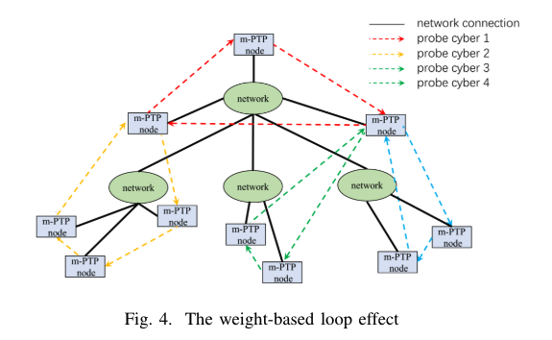

Paper: Sundial: Fault-tolerant Clock Synchronization for Datacenters
Sundia is a submicrosecond-level clock synchronization system that is resilient to failures, provides fast failure detection based on frequent synchronization messages in hardware. Sundial enables fast failure recovery using a novel graph based algorithm to precompute a backup plan that is generic to failures. It uses hardware-software codesign to quickly detect failures and recover from them.
Unlike Huygens which uses only software to improve clock synchronization, sundial is a hardware-software based solution.
Sundial is compared with Huygens along with other recent submicrosecond level clock synchronization schemes.
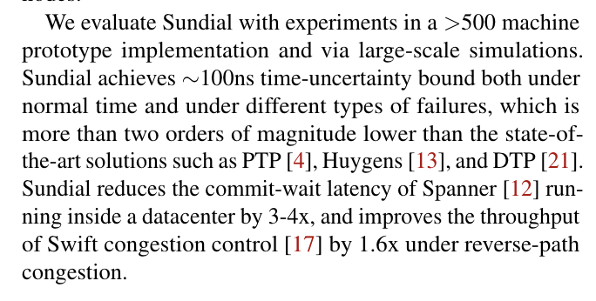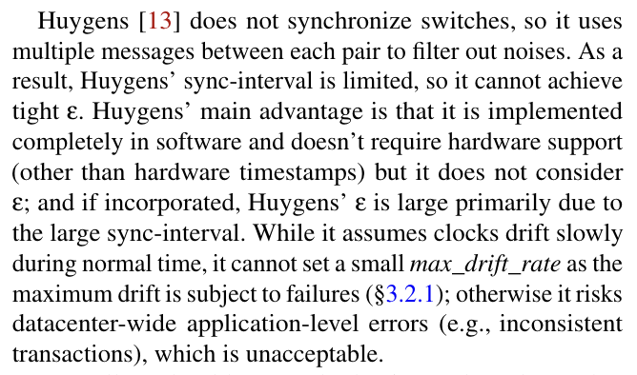
It is not like huygens which uses SVM for clock synchronization.
Paper: Graham: Synchronizing Clocks by Leveraging Local Clock Properties
Graham is using temperature-clock error relationship to plot curve, once the curve is formed, the time error is fixed. It works alongside clock synchronization mechanisms like Huygens to further improve efficiency and it does not use ML.
The below info is from the paper:
“ground truth”, or the temperature-clock error response curve. If we can determine the clock error given a certain temperature, then we can correct the clock even in the absence of the accurate timing signal.
The overall approach of Graham is to learn the temperature-clock error relationship by fitting curves as new data points are learned. Unlike the experiments we designed when trying to learn the ground truth, we cannot expect to be able to point a hair dryer or dump a production server in ice. In addition, since a truly scalable solution should not require a precise PPS timing signal, we need to ensure that we can perform this learning with traditional synchronization protocols such as NTP or PTP. As a result, Graham must fit these curves over time on incomplete and noisy data. Once we determine that the we have observed enough data points, we can use the derived curve to correct the time error. To fit this data on a curve, we begin by formalizing the variables and equations required to solve for the time error.
Graham works in synergy with other synchronization mechanisms, such as Huygens [14], PTP [10] and FaRMv2 [28] to maintain synchronization. Our experiments with NTP show that Graham can maintain 1µs ε for 10 seconds after loss of synchronization. As Sundial [20] shows, however, missed synchronizations can occur for a number of reasons. For Huygens, significant CPU load on the system could occur causing the SVM processing to be delayed, and in PTP and FaRMv2, synchronization messages could be missed, leading to increased uncertainty of time. Using our 1µs holdover result for Graham, we could reduce the standard 1s synchronization frequency of PTP to 3s and tolerate 2 lost synchornization messages.
Paper: Communication-efficient Clock Synchronization
This paper is an enhancement to the HUYGENS clock synchronization. The below snippet is from the paper. It claims to reduce the communication time between the master node and the server node but they are not enhancing it by improving the SVM model, so I believe it is not relevant to our study.
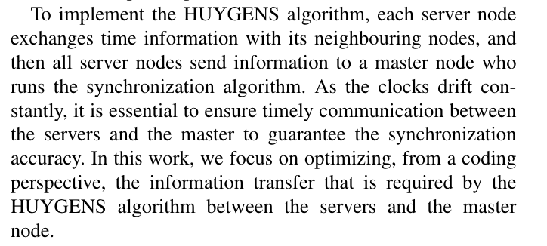

Few other papers are:
Anticipating synchronization with machine learning – This is an unrelated paper as from what I understand, it is synchronization in Complex Networks and Dynamic Systems

Real Time Empirical Synchronization of IoT Signals for Improved AI Prognostics
Clock synchronization in industrial Internet of Things and potential works in precision time protocol: Review, challenges and future directions – A comparison between the existing clock synchronization algorithms.

